|  |  |  |  |  |  |  |  |  |  |  |  |  |
| --- | --- | --- | --- | --- | --- | --- | --- | --- | --- | --- | --- | --- |
| **DEPARTMENT OF MECHANICAL ENGINEERING**  **Reverse Engineering-21MEC1671**  **Reverse Engineering and 3-D Printing Mini Project**  **Report**     |  |  |  | | --- | --- | --- | | **Student Name** | USN | **Marks Awarded (Max 10 Marks)** | | Sagarika Pattabhi | 1BG21AI092 |  | | Varsha S | 1BG21AI117 |  | | Vidhyashree S | 1BG21AI120 |  |     **Dr. Raghavendra N**  Professor  Dept. of ME, BNMIT |

**Reverse Engineering -21MEC1671**

**Alternate Assessment (10 Marks)**

**Project: Reverse Engineering an object through Scanning and 3-D Printing**

**1) Reverse Engineering of USB-C Cover**

**Name and Photo of the System/Device/Assembly USB-C Cover**

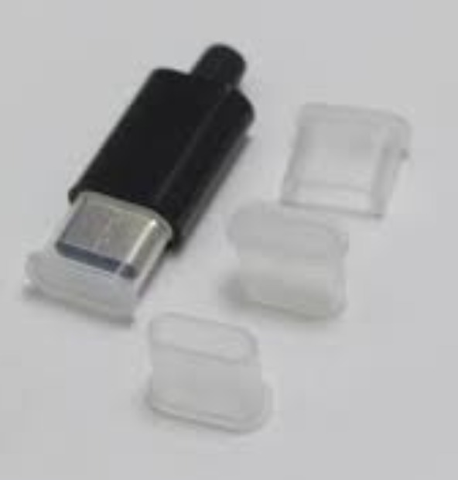

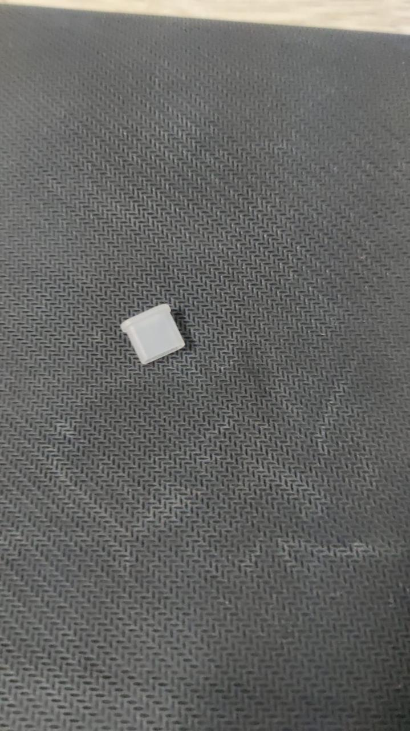

**CAD Model after scanning**

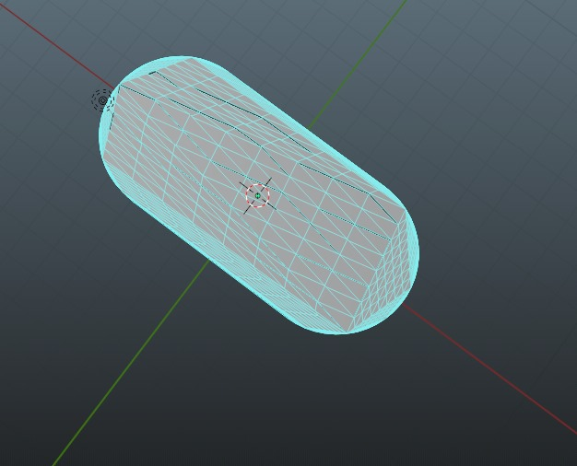

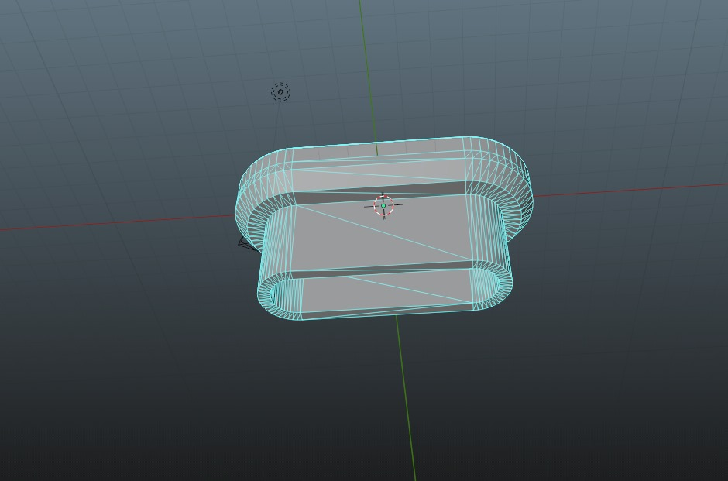

**STL model**



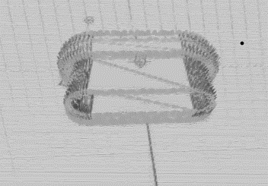

**3-D printed model**

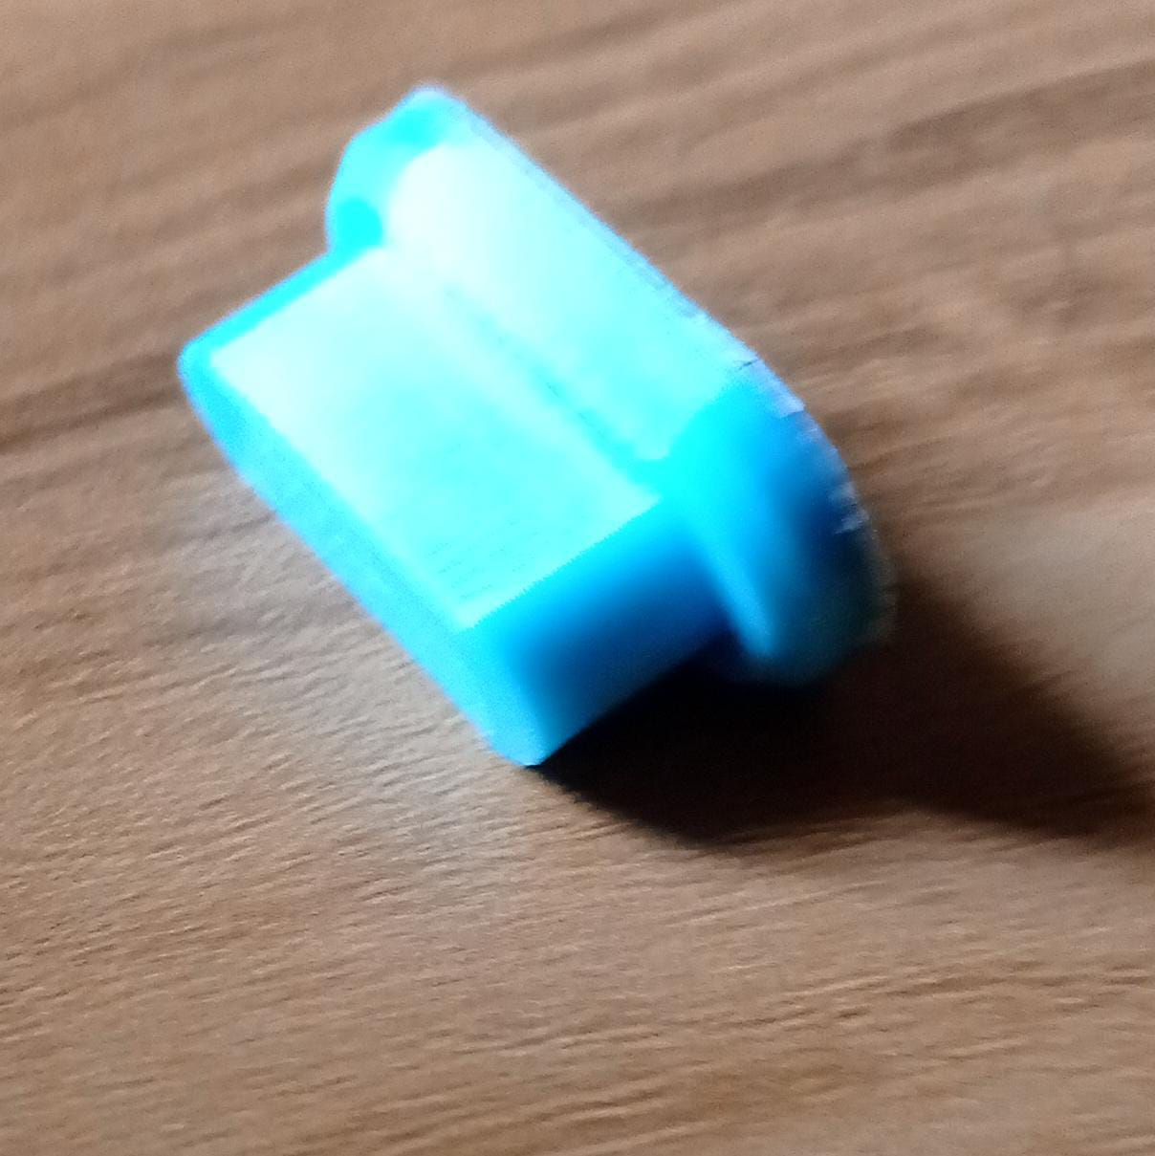

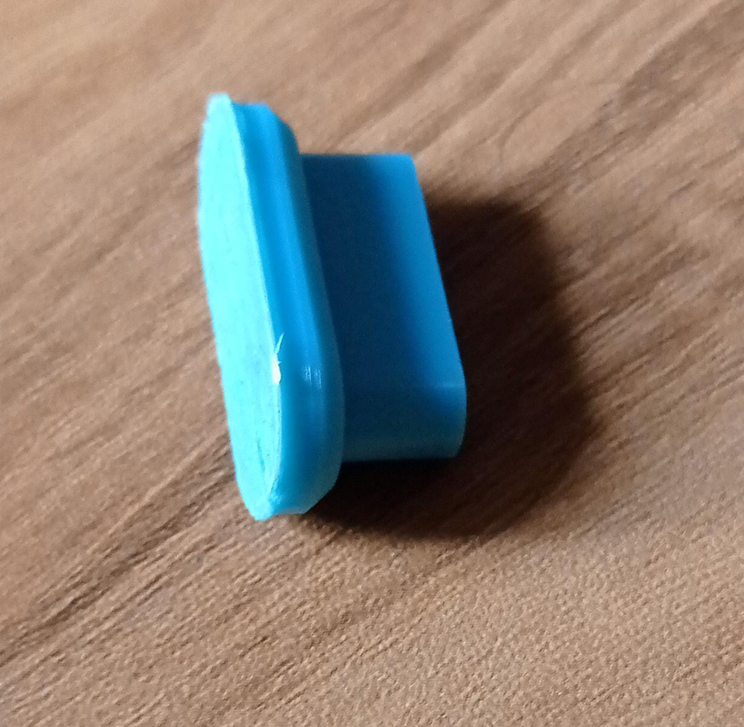

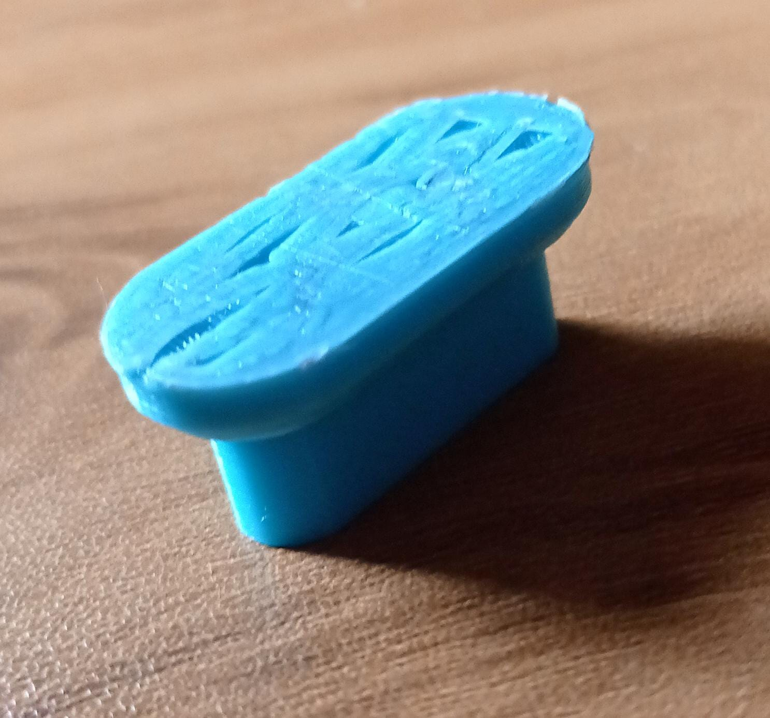

### Original Object

The original object in this reverse engineering project is a USB-C cover. This essential component is designed to protect the USB-C port from dust, debris, and physical damage. The cover is typically made of durable plastic and features precise dimensions to fit snugly over the USB-C port.

### CAD Model

The CAD (Computer-Aided Design) model represents the digital reconstruction of the USB-C cover created from the scanned data. After the initial 3D scanning, the point cloud data is converted into a mesh model, which is then imported into CAD software. Here, the model undergoes meticulous refinement to correct any imperfections and ensure all dimensions and features are accurate. The CAD model serves as a detailed blueprint, enabling precise modifications and optimizations before proceeding to the 3D printing stage.

### STL File

The STL (Stereolithography) file format is specifically used for 3D printing, containing the surface geometry of the CAD model without any color, texture, or other attributes. The CAD model is exported as an STL file, which simplifies the complex surfaces into a series of triangular facets. This format ensures that the 3D printer can accurately interpret the model's geometry, preparing it for the slicing process that dictates how the object will be printed layer by layer.

### 3D Printed Model

The 3D printed model is the final physical representation of the USB-C cover, produced from the STL file. Using a 3D printer, the object is created layer by layer, following the precise instructions generated from the STL file. The material used, typically a type of plastic, is deposited in successive layers to build the object. Once printing is complete, the model may undergo post-processing steps such as the removal of support structures and surface finishing. The result is a tangible USB-C cover that matches the original's dimensions and functionality, demonstrating the successful application of reverse engineering techniques.

**Software and Hard ware used for project**

### 1. Hardware:

1. **3D Scanner**: A device used to capture the physical dimensions and features of the USB-C cover, creating a digital representation.
2. **3D Printer**: Used to produce a physical model of the scanned USB-C cover from the digital STL model.
3. **Computer**: Necessary for running the scanning and 3D printing software, as well as for processing the CAD and STL files.
4. **USB-C Cover**: The physical object being reverse engineered.

### Software:

1. **CAD Software**: Used for creating and editing the 3D model of the USB-C cover after scanning.
2. **Scanning Software**: Software that processes the data from the 3D scanner to create a digital model of the object.
3. **3D Printing Software**: Converts the CAD or STL files into instructions for the 3D printer, managing the printing process.

**Procedure Followed for Scanning and 3-D printing**

The reverse engineering project of the USB-C cover involves several key steps to ensure accurate scanning and high-quality 3D printing. The procedure can be outlined as follows:

1. **Preparation**: The USB-C cover is prepared for scanning. This includes cleaning the surface to ensure no dust or debris affects the scan quality. The object is placed in an optimal position to capture all necessary details.
2. **3D Scanning**: A 3D scanner is used to capture the physical dimensions and features of the USB-C cover. The scanner uses laser or structured light to create a detailed digital model of the object. The scanning software processes the captured data to generate a point cloud, which is then converted into a mesh model.
3. **CAD Modeling**: The mesh model obtained from the scan is imported into CAD software. Here, the model is refined and edited to ensure accuracy. Any imperfections or gaps in the mesh are corrected, and the final CAD model is prepared.
4. **STL File Generation**: The CAD model is exported as an STL (stereolithography) file, which is the standard format used for 3D printing. This file contains the geometric information needed for printing.
5. **3D Printing**: The STL file is imported into 3D printing software, where it is sliced into layers and prepared for printing. The 3D printer is set up with the appropriate material, and the printing process begins. The printer builds the object layer by layer, following the instructions from the STL file.
6. **Post-Processing**: Once the printing is complete, the printed USB-C cover is removed from the printer. Any support structures used during printing are removed, and the object is cleaned and polished if necessary to achieve the desired finish.